ARM KNITTED SCARVES
GET STARTED ON YOUR CHRISTMAS GIFTS
November 3 @ 10:30
MENDON TOWNSHIP LIBRARY
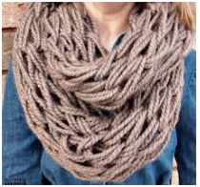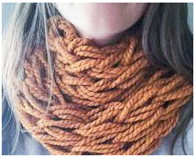
A MINIMUM OF 2 SKEINS OF YARN ARE NEEDED TO MAKE THE COWL TYPE SCARF USING TWO STRINGS.
3 SKEINS OF YARN ARE NEEDED TO MAKE THE THREE-STRINGED SCARF.
YOU COULD ALSO USE LEFT-OVER YARN AND WE COULD TIE PIECES TOGETHER. PLEASE DON’T CONSIDER USING SHORT PIECES, WE’D NEVER GET DONE.
THIS SHOULD TAKE ABOUT AN HOUR.

