Paint Date
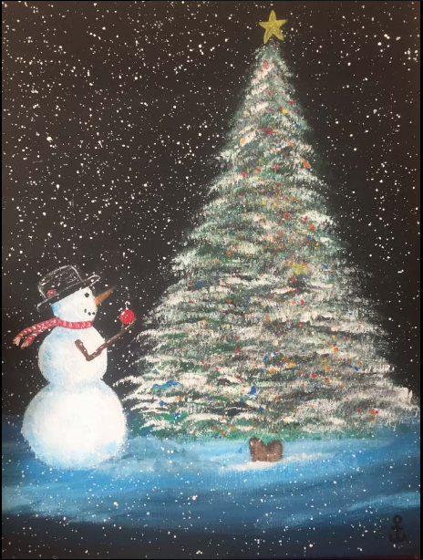
Paint Date and the Mendon Township Library will host a paint night November 15 at 6:00 p.m. in the lower level of the library. Price is $30.00 with a portion of the proceeds going to the Mendon Township Library. Refreshments and snacks will be provided. We will be painting "The First Ornament ". Hope you can come out and join us for a fun night of painting.

